**(CL-219) Database Systems Lab**

**Spring 2021**

**FAST-NU Peshawar Campus**

**Assignment #02**

**Name: Basharat Hussain**

**Roll no: P17-6102**

**Database lab**

**Dated: 6/11/2021**

**Question # 01**

CREATE TABLE Courses (

course_code varchar(10) NOT NULL,

course_name varchar(30) NOT NULL,

credit_hours varchar(30) NOT NULL,

roll_no varchar(10) NOT NULL,

PRIMARY KEY (course_code),

FOREIGN KEY (roll_no) REFERENCES student (roll_no) ON DELETE CASCADE

)

Course_registration_form.php

<!DOCTYPE html>

<html>

<head>

    <title>Registration Form</title>

    <link rel="stylesheet" href="https://stackpath.bootstrapcdn.com/bootstrap/4.3.1/css/bootstrap.min.css" integrity="sha384-ggOyR0iXCbMQv3Xipma34MD+dH/1fQ784/j6cY/iJTQUOhcWr7x9JvoRxT2MZw1T" crossorigin="anonymous">

</head>

<body>

<?php

error_reporting(0);

$servername = "localhost";

$username = 'root';

$password = '';

try {

  $conn = new PDO("mysql:host=localhost;dbname=university", $username, $password);

  // set the PDO error mode to exception

  $conn->setAttribute(PDO::ATTR_ERRMODE, PDO::ERRMODE_EXCEPTION);

  echo "Connected successfully";

} catch(PDOException $e) {

  echo "Connection failed: " . $e->getMessage();

}

?>

<div>

<?php

$course_code = $_POST['course_code'];

$course_name = $_POST['course_name'];

$credit_hours =$_POST['credit_hours'];

$stmt =$conn->prepare( "INSERT INTO Courses VALUES ('$course_code','$course_name','$credit_hours')");

$stmt->execute();

if($stmt){

    echo "Data is inserted Sucessfully";

}

?>

</div>

<center>

<div>

<h2> Course Registration Form </h2>

<form action="course_registration_form.php" method="POST">

Course Code: <input type ="text" name = "course_code" value="" /><br></br>

Course Name: <input type ="text" name = "course_name" value="" /><br></br>

Credits: <input type ="text" name = "credit_hours" value="" /><br></br>

<input type="submit" name="submit" value="Submit"/>

 </form>

</div>

</center>

</body>

</html>

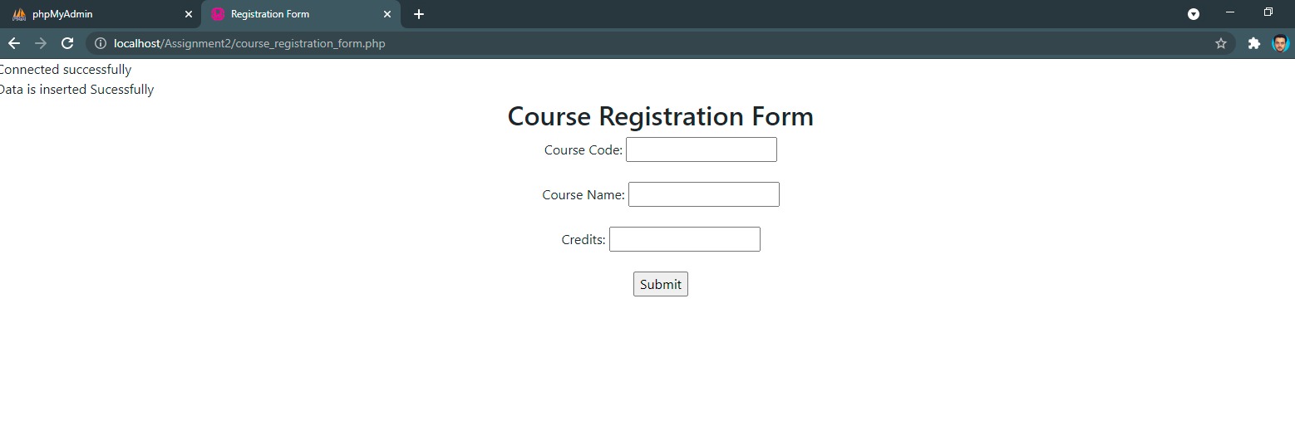

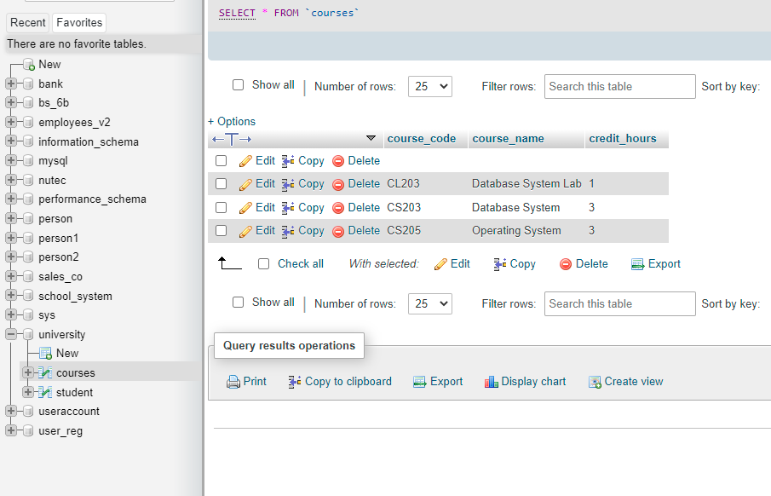

**Question # 02**

CREATE DATABASE person1;

SHOW databases;

USE person1;

CREATE TABLE Users(

user_id int NOT NULL,

username varchar(10) NOT NULL,

password varchar(10) NOT NULL,

email varchar(20) NOT NULL,

PRIMARY KEY(user_id)

);

CREATE TABLE Summary(

id int NOT NULL,

total_users int NOT NULL,

Yahoo_users int NOT NULL,

Outlook_users int NOT NULL,

Gmail_users int NOT NULL,

PRIMARY KEY(id)

);

INSERT INTO Users(user_id,username,password,email)

VALUES ('1','Salman','1234','salman@gmail.com');

INSERT INTO Users(user_id,username,password,email)

VALUES ('2','Harry','9090','harry@outlook.com');

INSERT INTO Users(user_id,username,password,email)

VALUES ('3','Atif','Pak123','atif@yahoo.com');

INSERT INTO Users(user_id,username,password,email)

VALUES ('4','Fawad','Pesh098','fawad@gmail.com');

INSERT INTO Users(user_id,username,password,email)

VALUES ('5','Mehwish','asd','mehwish@yahoo.com');

INSERT INTO Users(user_id,username,password,email)

VALUES ('6','Babar','Qwe876','baber@yahoo.com');

INSERT INTO Summary(id,total_users,Yahoo_users,Outlook_users,Gmail_users)

VALUES ('1','6','3','1','2');

DELIMITER $$

CREATE TRIGGER UPDATE_RECORD before UPDATE

on person1.Users

for each row begin

UPDATE Summary

SET new.Yahoo_users = new.Yahoo_users + 1 and new.Gmail_users = new.Gmail_users -1

where new.email LIKE '%yahoo.com%' and old.email like '%gmail.com%';

SET new.Outlook_users = new.Outlook_users + 1 and new.Gmail_users = new.Gmail_users -1

where new.email LIKE '%outlook.com%' and old.email like '%gmail.com%';

SET new.Gmail_users = new.Gmail_users + 1 and new.Yahoo_users = new.Yahoo_users -1

where new.email like '%gmail.com%' and old.email like '%yahoo.com%';

SET new.Outlook_users = new.Outlook_users + 1 and new.Yahoo_users = new.Yahoo_users -1

where new.email like '%outlook.com%' and old.email like '%yahoo.com%';

SET new.Gmail_users = new.Gmail_users + 1 and new.Outlook_users = new.Outlook_users -1

where new.email like '%gmail.com%' and old.email like '%outlook.com%';

SET new.Yahoo_users = new.Yahoo_users + 1 and new.Outlook_users = new.Outlook_users -1

where new.email like '%yahoo.com%' and old.email like '%outlook.com%';

END $$

DELIMITER ;

Course_enrollment.php

<!DOCTYPE html>

<html>

<head>

    <title>Registration Form</title>

</head>

<body>

<?php

error_reporting(0);

$servername = "localhost";

$username = 'root';

$password = '';

try {

  $conn = new PDO("mysql:host=localhost;dbname=university", $username, $password);

  // set the PDO error mode to exception

  $conn->setAttribute(PDO::ATTR_ERRMODE, PDO::ERRMODE_EXCEPTION);

  echo "Connected successfully";

} catch(PDOException $e) {

  echo "Connection failed: " . $e->getMessage();

}

?>

<center>

<div class="container ">

<form action="course_enrollment_form.php" method="POST">

<h3> Search Student </h3>

Roll No: <input type ="text" name = "roll_no" value="" /><br></br>

<input type="submit" name="search" value="Search"/>

 </form>

</div>

<?php

$conn = mysqli_connect("localhost", "root", "");

$db =mysqli_select_db($conn,'university');

if(isset($_POST['serach']))

{

    $query ="SELECT * FROM 'student' where roll_no like %search%";

    $query_run = mysqli_query($conn,$query);

while ($row = mysqli_fetch_array($query_run))

{

    ?>

   <tr>

    <td> <?php echo  $row['roll_no'] ?></td>

    <td> <?php echo  $row['st_name'] ?></td>

    <td> <?php echo  $row['l_name'] ?></td>

    <td> <?php echo  $row['gender'] ?></td>

    <td> <?php echo  $row['contact'] ?></td>

    <td> <?php echo  $row['address'] ?></td>

    </tr>

    <?php

}

}

?>

</center>

</body>

</html>